Beauty and Joy of Computing Unit 1 Assessment
Create an eCard that meets all of the following specifications:
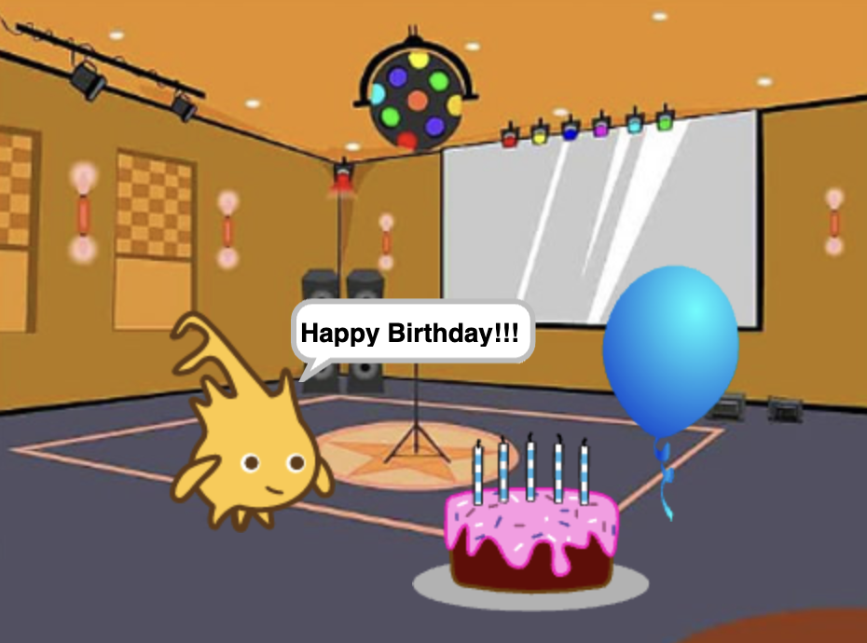
- Has a message for the viewer (such as "Happy New Year," "Happy Birthday," "Get Well Soon," etc.)
- Has stage background and sprite costumes
- Includes a custom block. This can be either:
  - A start over block that resets the eCard to the beginning (resets pen, stage, and sprites) OR
  - Another custom block containing multiple blocks that contributes to the purpose of the program (this could move a sprite, change the background, etc.)
- Includes iteration through the use of the repeat, repeat until, or for block.
- Lets the user interact (such as by clicking a sprite, pressing a key, or moving the mouse, etc.)
- Includes one additional feature. For example, you can choose:
  - Sounds or music (using the play block and/or the "Sounds" tab)
  - The random block
Put a comment in your code identifying the additional feature and briefly describing what it does.

